**Nempnett Thrubwell Parish Council**

**Community Emergency Plan**

**Version: 01**

Date of Plan: April 2025

This Plan is next due for review on: April 2026

**If an emergency occurs, your first action should ALWAYS be to contact the emergency services by dialling 999**

**Map of area covered by plan is on Page 9**

**Supported by**

**Contents**

1. First things to do in the event of an emergency 3

2. Activating the community emergency plan 3

3. Communications in an emergency 4

4. Emergency Team initial actions 5

5. Checklist for Team Meeting: 6

6. Community resources and skills 7

6.1 Evacuation Assembly Points 7

6.2 Local Skills and Resources 7

6.3 Local Risk Assessment 8

7. Map of the Community 9

8. Emergency Contact numbers 10

9. Top Tips – Personal Resilience 12

10. Useful information 13

# **First things to do in the event of an emergency**

1. **Ring 999 to inform the Emergency Services and provide**

**CLEAR, CONCISE ACTUAL Actual information as soon**

**as possible**

1. **Contact the plan volunteers**
2. **Meet at the Coordinators Assembly Point**

**Primary Coordinator Assembly Point**

**Name of Venue: Nempnett Thrubwell Village Hall**

**Address of Venue: Nempnett Thrubwell, BS40 8YJ**

**In the event that the above location is inaccessible the following will be used:**

**Backup Coordinator Assembly Point**

**Name of Venue: Church of St Mary The Virgin**

**Address of Venue: Nempnett Thrubwell, BS40 8YH**

# **Activating the community emergency plan**

The Plan may be activated when:

* An emergency has occurred
* Warnings are received prior to an anticipated emergency
* Emergency services request support or are not able to attend immediately.
* No emergency / warning has occurred but it is felt a community response would be of benefit, particularly for more vulnerable residents e.g. prolonged cold snap and icy conditions.

Until help arrives and without endangering yourself or other local people **contact the appropriate members of the community listed in the plan and ask them to report to the agreed assembly point**.

When the emergency services or other responders have arrived try to make contact with them, explain who you are and what your role is.

|  |  |  |  |  |
| --- | --- | --- | --- | --- |
| Role | Name | Tel | Mobile | Address |
| Coordinator | Peter Hellier | 01761 462039 | 07826 572217 | Kings Cottage, Nempnett Thrubwell, BS40 8YW |
|  |  |  |  |  |
| Deputy | John Mallone | 01761 462748 | 07914 960774 | 3 Lakeside Close, Nempnett Thrubwell, Chew Stoke, Bristol, BS40 8YT |
| Team Member 1 | Ingrid Wilms |  | 07814 812228 | Nempnett Cottage, Nempnett Street. BS40 AYW |
| Team Member 2 | James Everett | 01761 462633 | 07767 244312 | Church Lea, Dewdown Lane, Nempnett Thrubwell, BS40 8YH |

* The Plan can be activated by the Emergency coordinator based on that person’s assessment of the situation. It is easier to stop the plan should events come under control sooner than expected than to not respond at all.
* Sometimes full plan activation will not be required and the plan should also be seen as a resource to solve smaller issues within the community
* If details of an incident are received from a source other than the emergency services or local authority then those receiving the notification must contact the emergency services to ensure they are aware of the incident. This may require making a 999 call.

# **Communications in an emergency**

If appropriate, and safe the Emergency Team should aim to meet face to face to assess and give direction

The primary communications channels are:

* Nempnett Neighbours WhatsApp Group administered by Gill Ford.

# **Emergency Team initial actions**

**On receipt of the initial contact**

* If it comes from the emergency services or BANES, note their immediate requirements, if any.
* If it comes from another source:
  + Ensure that the emergency services are aware of the incident
  + If necessary call 999
  + Contact the Co-ordinator (or next in line) and decide if the plan should be activated (in full or in part)

**Assembly points for the emergency team**

* Primary assembly location: Village Hall, Nempnett Thrubwell
* Backup assembly location: Church of St Mary The Virgin, Nempnett Thrubwell

**Emergency team members should:**

* Assemble at designated assembly point
* Make initial contact with BANES and/or the emergency services
* Review the situation and identify/take actions (if safe to do so)
* Keep a log of proceedings and update each other on actions
* When the emergency services or other responders arrive, make contact with them, agree roles and actions and follow their lead.

# **Checklist for Team Meeting:**

1. **Assess the current situation**

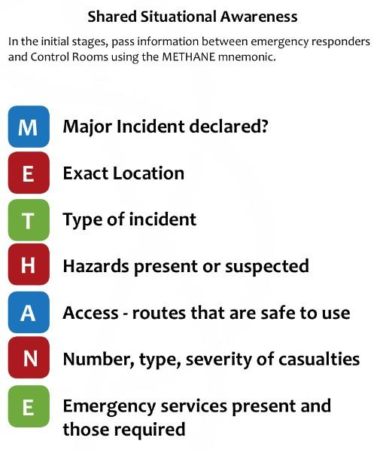

1. **Allocate roles, such as:**
   1. Coordination, communications, contacting those with the relevant local skills and resources, contacting vulnerable residents, opening up assembly/evacuation centres, gathering further information on the incident.
2. **Communications**
   1. Are WhatsApp and/or phone systems available (or is door knocking required)?
   2. Contact the community group coordinators to start cascade
   3. Contact people with relevant skills and resources
3. **Establishing contact with the emergency services**
   1. Pass on any useful information (use METHANE)
   2. Agree roles, communications and resources required
   3. Follow lead taken by responders
4. **What actions can be safely taken (eg. If emergency services delayed)**
   1. Supporting the vulnerable
   2. Opening up assembly points ( and stationing a team member there)
   3. Contacting people on the resources/skills list

# **Community resources and skills**

## **6.1 Evacuation Assembly Points**

Record here details of accommodation that would be suitable for persons, including casualties, requiring temporary shelter until help arrives e.g. halls, hostels, churches etc. Local authority premises, schools, leisure/community /day centers will be opened by the local authority as appropriate.

|  |  |  |  |  |  |
| --- | --- | --- | --- | --- | --- |
| **Key Holders Name** | **Facility Address** | **What3Words** | **Telephone No.** | **Mobile No.** | **Email Address** |
| Gill Ford | Village Hall, Nempnett Thrubwell, BS40 8YJ | Glorified. impulse. lightbulb |  | 07884 187391 | nempnett88@gmail.com |
| Diana Bellamy | Village Hall, Nempnett Thrubwell, BS40 8YJ | Glorified. impulse. lightbulb |  | 07770 314514 |  |
|  |  |  |  |  |  |
|  |  |  |  |  |  |

Ensure that the managers of these buildings are aware of their inclusion in this Plan, and that they are briefed as to what might be expected of them in an emergency i.e. to open the building, provide shelter (including heating if appropriate) and refreshments to evacuees.

## **6.2 Local Skills and Resources**

Resources available within the community include:

* 4 wheel drives, tractors and trailers – George Ford, Brinsley Barn, Nempnett Thrubwell. BS40 7UZ. Mobile: 07843 805949. George@nempnettpastures.co.uk

Skills available within the community include:

|  |  |  |  |  |  |
| --- | --- | --- | --- | --- | --- |
| Name | Skills |  |  | What3words | Mobile No. |
| Dr Elinor Rendle | First aid | Local GP | West Town House, West Town Lane, BS40 7XE | Copycat.launcher.adding | 07790 666834 |

**Defibrillator**

Location: Village Hall, Nempnett Thrubwell, BS40 8YJ

What3Words: glorified.Impulse.lightbulb

## **6.3 Local Risk Assessment**

Known potential hazards

Low flying aircraft on their approach to Bristol Airport

Gas pipelines

Local catchment area – flooding

# **Map of the Community**

# **Emergency Contact numbers**

|  |  |  |  |
| --- | --- | --- | --- |
| **Name / Contact** | **Role** | **Daytime contact number** | **24hr contact number** |
| Emergency Services |  | 999 | 999 |
| Local Police Station: Broadbury Road Knowle West Bristol BS4 1JT |  | 999 | 999 |
| Local GP Surgeries | Chew Medical Practices, Chew Lane, Chew Stoke. BS40 8UE | 01275 332420 |  |
|  | Harptree Surgery, Bristol Road, West Harptree. BS40 | 01761 221406 |  |
|  | Langford, Surgery, Pudding Pie Lane, Langford. BS40 5EL | 01934 852906 |  |
| B&NES Council | Emergency Planning Duty Officer | 01225 394041 | 01225 47 7477 |
| Environment Agency | Floodline | 0345 9881188 |  |
| Bristol Water |  | 0345 702 3797 |  |
| Environment Agency | Incident Hotline | 0800 807060 | 0800 807060 |
| NHS Direct |  | 111 |  |
| Hospitals | Southmead Hospital, Southmead Road, Westbury on Trym. BS10 NB | 01179 505050 |  |
|  | BRI, Marlborough Street, Bristol. BS2 8HW | 01179 230000 |  |
|  | RUHB, Coombe Park, Bath. BA1 3NG | 01225 428331 |  |
| UK Power Networks - ELECTRICTY |  | 105 |  |
| National GAS Emergency Service 24 hours a day |  | 0800 111 999 |  |
| Bristol Airport Emergency number |  | 01275 473400 |  |

# **Top Tips – Personal Resilience**

**There is an important part to be played by individuals and households to help themselves at a personal level. There is a lot that individuals can do to cope better during, and recover quicker from, an emergency.**

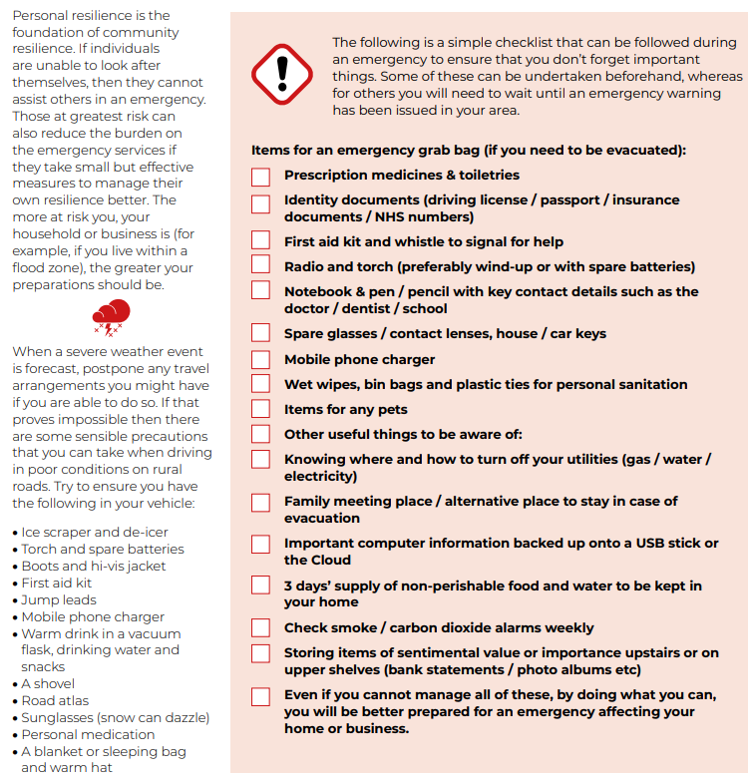

# **Useful information**

Avon and Somerset Local Resilience Forum (LRF) community risk register (a guide to the top 10 risks in this region and what you can do to be prepared in your home)

[**https://media.aspolice.net/uploads/production/20200107090454/Community-Risk-Register.pdf**](https://media.aspolice.net/uploads/production/20200107090454/Community-Risk-Register.pdf)

Registering as a vulnerable customer[**National Grid - Priority services**](https://www.nationalgrid.co.uk/customers-and-community/priority-services)

Bristol water register as vulnerable  
[**https://www.bristolwater.co.uk/home/account-and-services/your-account/priority-services**](https://www.bristolwater.co.uk/home/account-and-services/your-account/priority-services)

Wessex Water report a problem  
[**https://www.wessexwater.co.uk/report-a-problem**](https://www.wessexwater.co.uk/report-a-problem)

Wessex Water register as vulnerable  
[**https://www.wessexwater.co.uk/help-and-advice/priority-services**](https://www.wessexwater.co.uk/help-and-advice/priority-services)

Weather warnings and advice (Met Office)   
[**UK weather warnings - Met Office**](https://www.metoffice.gov.uk/weather/warnings-and-advice/uk-warnings#?date=2022-10-11)

Flood alerts and guidance[**How to plan ahead for flooding - Check for flooding - GOV.UK (check-for-flooding.service.gov.uk)**](https://check-for-flooding.service.gov.uk/plan-ahead-for-flooding)

Flood maps are available online[**Flood map for planning - GOV.UK (flood-map-for-planning.service.gov.uk)**](https://flood-map-for-planning.service.gov.uk/)

A guide to rural community resilience is available on the communities prepared website[**Building resilience in rural communities – Communities Prepared**](https://www.communitiesprepared.org.uk/2020/06/building-resilience-in-rural-communities/)